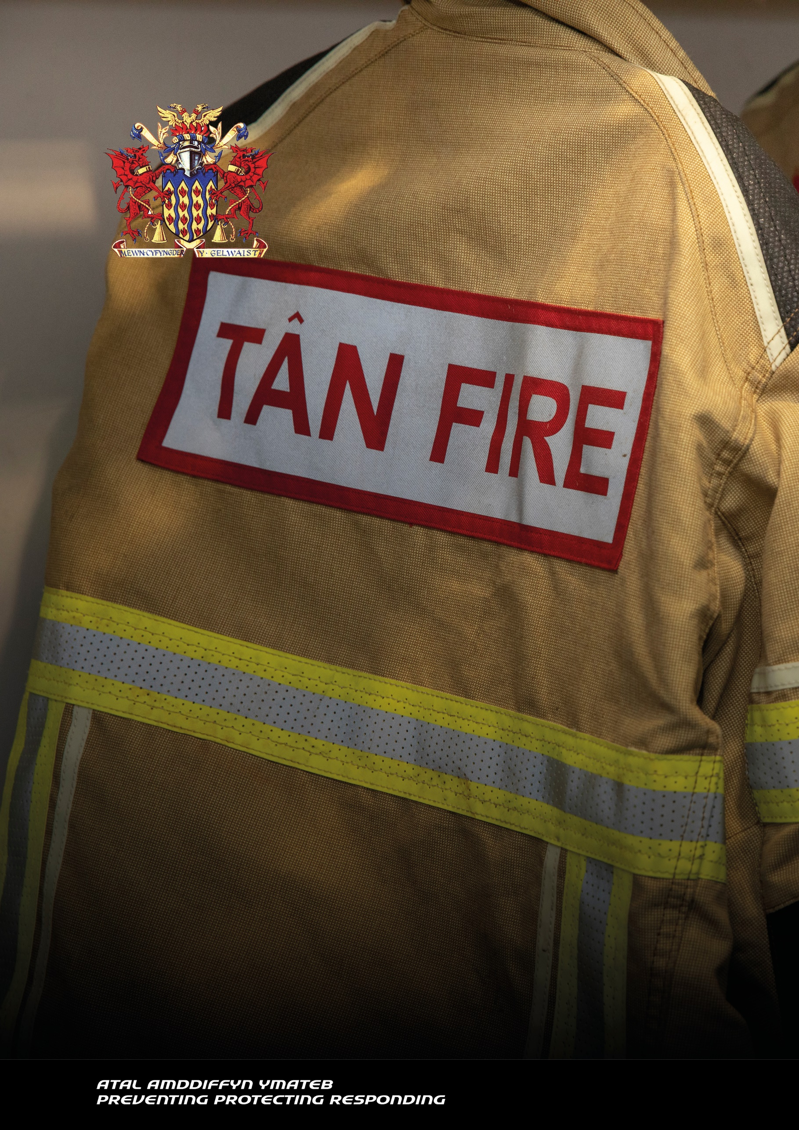

**Draft**

**ANNUAL GOVERNANCE**

**STATEMENT 2024-25**

North Wales Fire and Rescue Authority

ANNUAL GOVERNANCE STATEMENT ON INTERNAL CONTROL

For the year ended 31 March 2025

This Statement has been prepared in accordance with The Accounts and Audit (Wales) Regulations 2014 and the guidance produced by the Chartered Institute of Public Finance and Accountancy (CIPFA) and the Society of Local Authority Chief Executives (SOLACE), the ‘Delivering Good Governance in Local Government Framework’ 2016. The relationships between the seven principles for good governance in the public sector are illustrated below.

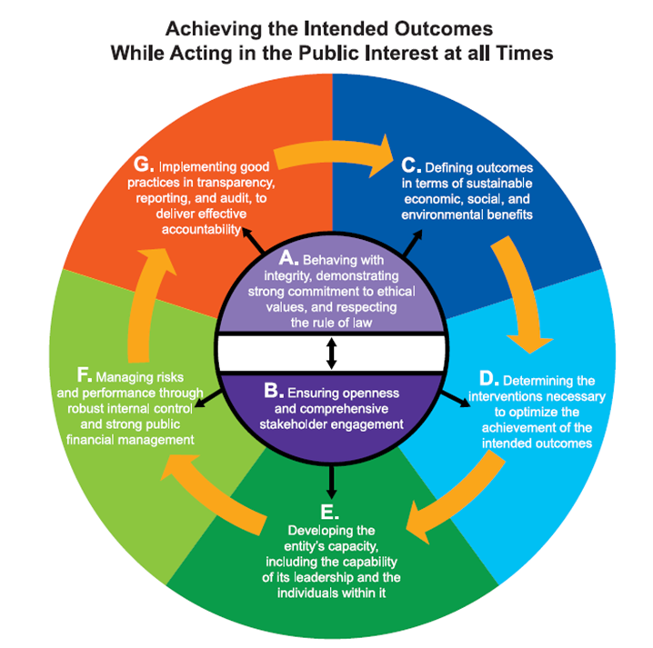

Fig. 1 How Principles for good governance relate to each other.

Source: international Framework-[Good Governance in the Public Sector](https://www.ifac.org/knowledge-gateway/supporting-international-standards/publications/international-framework-good-governance-public-sector)

This Annual Governance Statement explains how North Wales Fire and Rescue Authority (The Authority) has complied with the framework and its seven core principles of good governance to ensure that resources are directed in accordance with agreed policy and priorities.

**Scope of Responsibility**

North Wales Fire and Rescue Authority is responsible for ensuring that:

* business is conducted in accordance with all relevant laws and regulations
* public money is safeguarded and properly accounted for
* resources are used economically, efficiently, effectively and equitably to achieve agreed priorities which benefit local people.

In discharging its overall responsibility, Members and Senior Officers are responsible for putting in place appropriate arrangements for the governance of the Authority’s affairs and the stewardship of the resources at its disposal, which includes arrangements for the management of risk.

Strategic leadership is given by and discharged through the Authority and its various Committees, panels and working groups, which enable Members to decide on issues affecting the running of the Authority, in accordance with the principles of openness and democratic accountability.

**The Purpose of the System of Internal Control**

To fulfil its wide range of functions, the Authority must satisfy political, economic, social and environmental objectives over the short, medium and longer term. This subjects it to a different set of external and internal constraints and incentives from those found in the private sector, all of which affect its governance arrangements.

A key piece of legislation in Wales is the Well-being of Future Generations (Wales) Act 2015, which requires the Authority to consider the longer term in making its decisions and to work collaboratively with other public bodies to improve well-being in Wales.

Stakeholders are, therefore, interested in issues such as:

• whether the Authority’s planned outputs have been delivered and outcomes achieved, and

• whether this has been done in an efficient, economic, effective and equitable manner.

To deliver good governance in the public sector, both governing bodies and individuals working for public sector organisations must try to achieve their objectives while acting in the public interest at all times, which implies primary consideration of the benefits for society, which should result in positive outcomes for service users and other stakeholders.

This Statement gives assurances that North Wales Fire and Rescue Authority has complied with the governance framework for the year ended 31st March 2025.

**The Governance Framework**

North Wales Fire Authority comprises 28 elected councillors from the six unitary authorities of North Wales, with the number of representatives determined by the population of the area. More information about the Authority, its members and responsibilities can be found [here](https://www.northwalesfire.gov.wales/fire-and-rescue-authority/).

The Authority is required to review the effectiveness of its arrangements each year to ensure that there is a sound system of governance. The key contributors to this process include:

Having an Authority and committee structure that:

* monitors the effectiveness of risk management arrangements
* regularly reviews the governance arrangements
* considers and reviews internal and external audit strategies, plans and reports
* reviews, scrutinises and approves the annual statement of accounts.

Having an Executive Panel that:

* provides leadership on governance
* contributes to the completion and review of the Annual Governance Statement
* provides clear direction to the Service and senior managers.

The use of information from various sources to inform the governance arrangements, for example:

* improvement and performance board reports
* risk management arrangements
* external regulator reports
* internal audit reports

The Authority’s normal schedule of meetings are attended remotely. The full Fire and Rescue Authority meetings are webcast in Welsh and English simultaneously. All meetings are made available to the public to observe, should they make a request to do so.

Early in 2023, the Authority established two working-groups to support the development of two key organisational priorities:

* The Emergency Cover Review Working Group, which has now been superseded by a Collective Agreement Task and Finish Group with Trade Union representation but no longer any Fire Authority representation.
* The new Training and Development Centre Working Group.

In addition, a member of the Fire and Rescue Authority sits on the Equality, Diversity and Inclusion Committee as a member champion, and following the report of the CREST cultural review report the Chief Fire Officer now chairs a Cultural Board to manage the implementation of the Strategic Cultural Improvement Plan, which is due to be published on the Fire Authority website imminently.

In April 2025 the Authority approved the second of its Community Risk Management Implementation Plans ([CRMIP 2025/26](https://www.northwalesfire.gov.wales/media/cpdehdib/nwfrs-crmip-2025-2026-final-english-web.pdf)) to deliver against the objectives outlined in the five-year [Community Risk Management Plan (CRMP) 2024-2029](https://www.northwalesfire.gov.wales/media/342269/nwfrs-community-risk-management-plan-2024-2029.pdf)

A Community Risk Management Plan (CRMP) aims to identify risks facing the community and describes how the Fire and Rescue Authority will manage those risks and continue to prevent and respond to fires and other emergencies.

The Authority has developed [five principles](https://www.northwalesfire.gov.wales/about-us/community-risk-management-plan-2024-2029/our-five-principles/) for keeping communities safe and the CRMP;

* Acknowledges the requirements of key legislation
* Considers the ongoing work of the Public Services Boards
* Identifies the risks facing our communities
* Outlines what activity the Authority had taken to address these risks
* Explains what actions the Authority will take over the next five years to mitigate those risks
* 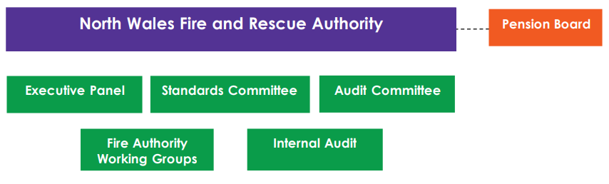Aligns with the Authority’s revenue budget, capital plan and medium-term financial plan. Fig 2. Committees of the Fire and Rescue Authority

The Authority has delegated responsibility for the day to day operation of the Fire and Rescue Service (the Service) to the Chief Fire Officer.

The Chief Fire Officer is supported by The Executive Group comprising the Principal Officers, (Chief, Deputy and Assistant Fire Officers) which is responsible for strategic leadership.

The Service Leadership Team (SLT), includes the Principal Officers, Area Managers and Heads of Department. It meets as a Performance Board to scrutinise performance, and as an Improvement Board to provide challenge and senior oversight of programmes, projects and policies. The SLT provides organisational leadership and service delivery.

The Service Governance and Assurance Structure of committees and groups, reporting to SLT, are embedded across the organisation, demonstrating robust governance across reporting, monitoring, scrutiny and decision-making within all areas of the organisation.

Chief Fire Officer

Service Leadership Team

5 Area Managers and 6 Heads of Department

Deputy Chief Fire Officer

North Wales Fire and Rescue Service

3 X Assistant

Chief Fire Officers

Fig 3. Service Leadership Structure

Key Contributors to Developing and Maintaining the Governance Framework

|  |  |
| --- | --- |
| Constitution | The purpose of the Constitution is to set out in clear language how the Fire Authority works and how it makes decisions |
| Fire Authority | Provides the strategic leadership, political interface and corporate challenge in relation to the provision of fire and rescue services across North Wales, encouraging public participation and conducting its affairs in an open and transparent manner. It agrees the Improvement and Wellbeing Plan, and the revenue and capital budgets |
| Executive Panel | Monitors the performance of the Service and makes recommendations to the Authority on its key policies including the Improvement and Wellbeing Plan. The Panel reviews the strategic risk register. |
| Audit Committee | Provides independent review of the governance, risk management and control frameworks and oversees the financial reporting, including the Treasury Management Strategy and annual accounts. |
| Standards Committee | Promotes and maintains high standards of conduct by Members of the Authority and oversees the whistle-blowing policy for complaints against Members of the Authority. Also, where statute permits, to receive reports and complaints about Members and to conduct or oversee investigations and make recommendations to the Authority. |
| Fire Authority Working Groups | Undertake detailed work associated with the Authority’s planning and budget-setting process. It submits its observations to the Executive Panel which in turn makes recommendations for improvement/risk reduction/well-being objectives to the Authority. |
| Executive Group | Implements the policy and budgetary framework set by the Fire Authority and provides advice to the Fire Authority on the development of future policy and budgetary issues. |
| Service Leadership Team | Sets and leads the implementation of the governance standards across the Service. Receives the annual improvement plan and feeds into the annual self-assessment. |
| Section 151 Officer | Ensures lawful and financially prudent decision making.  Administration of financial affairs.  Accountable for developing and maintaining the Fire Authority’s governance, risk and control framework.  Contributes to the effective corporate management and governance of the Fire Authority |
| Monitoring Officer | Reports on contraventions of any enactment or rule of law.  Reports on any maladministration or injustice where the Local Government Ombudsman has carried out an investigation.  Maintains and updates the Constitution.  Maintains registers of member interests and gifts and hospitality.  Advises Members on the interpretation of the Code of Conduct. |
| Internal Audit | Provides independent assurance and annual opinion on the adequacy and effectiveness of the Fire Authority’s governance, risk management and control framework.  Delivers an annual programme of risk-based audit activity, including counter fraud and investigation activity.  Makes recommendations for improvements in the management of risk. |

CIPFA Principles - Governance Assurance

**Principle A: Behaving with integrity, demonstrating strong commitment to ethical values, and respecting the rule of law.**

The Authority’s [Mission and Values](https://www.northwalesfire.gov.wales/media/339219/core-values-a3-bilingual-poster.jpg) are published in the Community Risk Management Plan and on the [Authority’s website](https://www.northwalesfire.gov.wales/fire-and-rescue-authority/).

The [Constitution](https://www.northwalesfire.gov.wales/media/340397/2022-02-constitution.pdf) sets out the responsibilities of the Fire and Rescue Authority and its committees and includes the Scheme of Delegation to Officers.

The Monitoring Officer ensures that decisions taken are within the law and comply with the provisions of the Constitution.

The Constitution includes the [Code of Conduct for Members](https://www.northwalesfire.gov.wales/media/1608/nwfa_-_members_code_of_conduct_-_0608.pdf) and this is monitored by the Standards Committee.

Where necessary legal advice is sought to inform decision making.

Codes of Conduct for Members and Officers are in place, which requires the declaration of business interests and recording of the receipt of gifts and/or hospitality. These are published on the Authority’s website as part of each [Member’s personal profile](https://www.northwalesfire.gov.wales/fire-and-rescue-authority/members/).

Key policies are in place to prevent and minimise the risk of fraud. Policies include: Whistleblowing Policy, [Anti-Fraud, Bribery and Corruption Policy](https://www.northwalesfire.gov.wales/media/1668/antifraud_corruption_policy_2014.pdf) and [Financial Regulations](https://www.northwalesfire.gov.wales/media/340526/financial-regulations-final-mar-2022.pdf) and [Contract Procedure Rules](https://www.northwalesfire.gov.wales/media/341720/nwfra-contract-procedure-rules-updated-nov-2021.pdf). Where irregularity is suspected arrangements are in place to ensure that it is thoroughly investigated.

The recruitment policy, induction and training processes incorporate personal behaviours with core values.

Reaccreditation of our Public Health Wales Corporate Health [Gold](https://phw.nhs.wales/services-and-teams/healthy-working-wales/healthy-working-wales-workplace-awards-ending/corporate-health-standard-award-holders/gold-award-holders/) and [Platinum](https://phw.nhs.wales/services-and-teams/healthy-working-wales/healthy-working-wales-workplace-awards-ending/corporate-health-standard-award-holders/platinum-award-holders/) awards, an award scheme run by Healthy Working Wales, on behalf of Public Health Wales. These awards allow employers to demonstrate policies and actions designed to promote happier and healthier workforces.

An Equality, Diversity and Inclusion (EDI) Steering Committee was established in 2022 and a five-year [Equality, Diversity and Inclusion Strategy](https://www.northwalesfire.gov.wales/media/342461/nwfrs-edi-strategy-2024-29-english.pdf) has been developed and published.

The implementation of the EDI strategy will be guided by a detailed annual EDI action plan, which will be performance-managed by the Equality, Diversity and Inclusion Committee which meet on a quarterly basis.

The service is committed to upholding standards and takes all concerns seriously. Disciplinary cases and any allegations of wrongdoing are

investigated in accordance with the Service’s Discipline Handbook. The Service has now recruited two Discipline and Grievance Officers, ensuring allegations are promptly and professionally investigated.

A [Welsh Language Standards Annual Report](https://www.northwalesfire.gov.wales/media/342076/final-annual-performance-assessment-22-23-amended-jan2024.pdf) is published on the Authority’s website detailing the Authority’s compliance with the Standards.

As part of our commitment to the Welsh language, all new members of staff are required to achieve a minimum of Level 2 Welsh language skills and Level 3 upon promotion.

The Community Risk Management Plan which contains Improvement and Well-being objectives is currently subject to public and stakeholder consultation. The ratified Five-year Plan and the 2024-25 Implementation Plan will be published on the Authority’s website. This meets our obligations as required by the Local Government (Wales) Measure 2009, and the Well-being of Future Generations (Wales) Act 2015.

A Safeguarding policy and procedure is in place to refer vulnerable people the Service come into contact with, to other agencies.

All departmental plans and policies, where applicable, demonstrate alignment to the Well-being of Future Generations (Wales) Act 2015

Safecall, a professional, confidential and independent service provides a means for concerns to be reported by any member of staff 24/7, 365 days of the year, and is widely publicised across the Service. The Service recognises the importance of offering anonymous reporting and engagement in sensitive situations.

The Service has adopted The Social Partnership Duty, and has built on well-established arrangements between the Service and staff representative bodies to consult on objectives and strategic decisions about how it intends to deliver those objectives. The first [Social Partnership Duty Annual Report](https://www.northwalesfire.gov.wales/media/kbfoievb/09i-social-partnership-duty-annual-report.pdf) was approved for publication and submission to the Social Partnership Council in April 2025.

**Principle B: Ensuring openness and comprehensive** **stakeholder engagement.**

All meetings are advertised and full Authority meetings are webcast. Agendas and papers are available on the Authority’s website.

Information is published on the Authority’s website as part of the publication scheme. Read/Speak and Welsh versions of documents are provided.

Public consultation arrangements are in place to invite the views of stakeholders prior to developing and implementing key changes. This includes consultation on the Improvement Objectives contained in the Community Risk Management Implementation Plan 2024-25.

The Authority has previously been recognised as achieving [‘Good Practice’ by the Consultation Institute](https://www.northwalesfire.gov.wales/media/341881/04-ecr-fire-authority-paper-final-draft.pdf) for all elements of the public consultation in connection with the ongoing Emergency Cover Review.

The commitment to openness is also shown through;

* completion of impact assessments for all key decisions;
* the Complaints and Compliments Procedure, which includes the ability to escalate significant matters;
* the Public Engagement and Consultation Strategy;
* engagement with Employee Representative Bodies, informally and formally through the Joint Consultation and Negotiation Committee, which will be further strengthened by the adoption of the Social Partnership Duty in the new financial year;
* a biennial commitment to engage with staff via the ‘Fire Family’ staff survey.
* membership of the Welsh Local Government Association, North Wales Equality Leads Forum, The Race Council Cymru and the North Wales Inter-Faith Forum.

A variety of engagement methods are used including:

* directed communication using social media, with accounts on Facebook and X. This includes both corporate accounts as well as social media accounts run by fire station staff to widen engagement in local communities;
* the ability to sign up for email updates on specific issues via the website;
* engagement with young people via the Phoenix programme, Fire cadets and school visits;
* community safety engagement with householders and businesses;
* a Positive Action group, chaired by the ED&I officer, to plan and direct events for all firefighter recruitment;
* attendance at open days/events – for example organised events like the Eisteddfod as well as fire station events organised by staff;
* internal communications include the Weekly Brief electronic newsletter to staff;
* external communications campaigns, led by the Community Safety Managers.
* through Prevent and Recruitment activities the service engages with people of all ages and diverse backgrounds.

Partnership arrangements are in place for;

* All Wales Joint Emergency Service Group currently chaired by the CFO;
* Local Resilience Forums;
* the three local Public Services Boards;
* the Regional Partnership Board;
* the Strategic Arson Reduction Board;
* the Local Safeguarding Adults Boards and Local Safeguarding Children’s Board;
* collaboration with other Emergency Services.

**Principle C: Defining outcomes in terms of sustainable economic, social and environmental benefits.**

The five-year Community Risk Management Plan sets the strategic direction for the Authority and details the improvement objectives in accordance with the Local Government (Wales) Measure 2009, and well-being objectives in accordance with the Well-being of Future Generations (Wales) Act 2015.

The Authority’s policies reflect the sustainable development principle of the Well-being of Future Generations Act (Wales) 2015.

The Medium-Term Resource Strategy, which includes a 10-year Capital Plan, and annual budget process aims to ensure that financial resources are directed to the Authority’s priorities.

The Service continues to ensure the mandatory e-learning is undertaken by all staff in respect of the Violence Against Women, Domestic Abuse and Sexual Violence Act.

As a [Disability Confident](https://www.gov.uk/government/publications/disability-confident-employers-that-have-signed-up) employer, the Service is committed to recruiting and retaining disabled people and those with health conditions.

The Service has also signed the [Armed Forces Covenant](https://assets.publishing.service.gov.uk/media/5e7a1803d3bf7f52f03c89ff/North_Wales_Fire_and_Rescue_Service_Armed_Forces_Covenant_20200207.pdf), which is a promise by the nation to ensure that those who serve or who have served in the armed forces, and their families, are treated fairly. This is supported by an Armed Forces Reserves and Veterans Policy.

The Service pays [above the real living wage](https://www.northwalesfire.gov.wales/media/341197/11-pay-policy-statement-2023-24.pdf).

A Safeguarding policy and procedure are in place to refer vulnerable people the Service come into contact with, to other agencies.

The appropriate criminal records checks are crucial to the Service to understand and mitigate risk, to protect colleagues and the public. Fire and Rescue Authorities are now listed in Schedule 1 Rehabilitation of Offenders 1974 (Exceptions) and as such, all employees are now eligible for a Standard level DBS check as a minimum level and these are now renewed on a three-yearly cycle.

The Service has a statutory duty to put in place business continuity arrangements. Plans across the Service are reviewed annually and there is ongoing collaboration with the other fire and rescue services in Wales to improve planning and consider current risks.

Key decisions are subject to an integrated impact assessment, which takes account of equality; data protection; health, safety and wellbeing; Welsh language; finance; sustainability and staffing; Well-being of Future Generations (Wales) Act 2015 and the socio-economic duty and it will also take account of the anticipated statutory Health Duty.

The Authority has developed and adopted an Environmental Strategy which sets out detailed and robust performance targets for a reduction of our carbon emissions and other significant environmental impacts.

**Principle D: Determining the interventions necessary to optimise the achievement of the intended outcomes.**

Public consultation is carried out as part of setting the Authority’s objectives which are set out in the Community Risk Management Implementation Plan.

An assessment of the Authority’s performance against its annual objectives is published in October each year.

The Authority’s Strategic Risk Management Policy (which is currently being reviewed following internal audit) sets out the process used to identify and control exposure to uncertainty, which may impact on the achievement of the objectives or activities. This is reviewed throughout the year to ensure that risks are appropriately managed.

Following scrutiny from the Executive Group, performance and financial reports are presented to the Authority and its committees.

A quarterly Performance Monitoring Report is prepared for the Executive Panel and the Service Leadership Team scrutinise data relating to incident demand, emerging trends, and availability at the Performance Board, ensuring that issues are identified and appropriate interventions agreed.

The budget planning processes, involving Service leads and Authority Members, ensure budgets are allocated to support risk-based objectives whilst balancing the costs associated with maintaining estates, vehicles and equipment. The Budget, Monitoring and Procurement Committee provides the necessary strategic oversight and governance.

The Organisational Learning Committee provides strategic oversight and governance of National Operational Guidance and Joint Operational Learning available and implements any necessary changes.

Health and Safety incidents are reported, reviewed and monitored to ensure the safety of all staff is optimised and risks are minimised. The Health Safety & Wellbeing Committee has strategic oversight and governance.

The [All Wales Dwelling Fire Response Charter](https://www.northwalesfire.gov.wales/media/3763/12_dwelling_fires_response_charter_appx_1.pdf) sets out seven high-level commitments in respect of preventing and responding to dwelling fires. It is reported upon annually as part of the Authority’s Annual Performance Assessment.

**Principle E:** **Developing the entity’s capacity, including the capability of its leadership and the individuals within it.**

The Authority’s Constitution outlines the roles of elected members and designated officers to enable shared understanding of roles and objectives.

The designated posts include the Chief Fire Officer, Treasurer and Monitoring Officer.

Regional and national collaborative working exists, for example, the three Welsh fire and rescue services participate in the All Wales Fire Investigation Training Forum, supporting shared learning and promoting a consistent approach across Wales.

The Authority has adopted the All Wales People and Organisational Development Strategy 2025-2028, which underpins the commitment to lifelong learning and workplace competence.

Induction processes for Members and employees include an introduction to the organisation’s core values, the standards of conduct and the role requirements.

The development needs of employees are identified through one to one meetings.

Health and wellbeing support is provided to maintain physical and mental wellbeing. This is achieved through a range of measures including HR policies and guidance documents, flexible working approach, the occupational health service and the employee assistance programme. The Health, Safety & Wellbeing Committee provides strategic oversight and governance.

The Service has a dedicated training department, with competency frameworks for operational staff. Training is delivered using a variety of methods including e-learning modules which are mandatory for certain subjects e.g. Data Protection. The Organisational Learning Committee provides strategic oversight and governance.

Staff are members of relevant professional bodies and undertake the required continual professional development.

The Service aligns its promotional processes to the National Fire Chiefs Council (NFCC) leadership framework.

**Principle F: Managing risks and performance through robust internal control and strong public financial management.**

The Treasurer is responsible for the proper administration of the Authority’s financial affairs as required by [Section 151 Local Government Finance Act 1972.](https://www.legislation.gov.uk/ukpga/1972/70/section/151)

The Monitoring Officer ensures compliance with established policies, procedures, laws and regulations.

The Strategic Risk Management Policy (which is currently being reviewed following internal audit) details the process for the identification and control of risks. A corporate risk register is maintained by the Corporate Planning Department and is monitored throughout the year.

Reports to the Authority and its committees include an integrated impact assessment to inform and support decisions.

Business continuity arrangements are in place to ensure that critical services can continue to be delivered at all times and reviewed annually.

The Authority’s Audit Committee ensure that recommendations for improvement made by the External Auditor, Audit Wales, and the Internal Auditor are agreed and monitored.

Members and senior management are provided with [quarterly reports](https://www.northwalesfire.gov.wales/media/342219/07-performance-monitoring-report-april-december-2023.pdf) on Service improvement and performance against key performance indicators and milestones.

The Authority has arrangements to maintain [registers of Members’ personal and business interests and a register of gifts and hospitality.](https://www.northwalesfire.gov.wales/fire-and-rescue-authority/members/) These are published on the Authority’s website as part of each Member’s personal profile.

Policies for Anti-Fraud and Corruption and Whistle-blowing are in place which confirms the Authority’s commitment to operating in a fair and transparent manner.

Policies and arrangements are in place to manage the handling of data. These are the Data Protection Policy, Freedom of Information Policy, Data Retention Policy and Communications and Information Security Policy. These policies are supplemented with training and the e-learning module on data protection is mandatory for all staff.

Information sharing protocols have been developed and agreed with partners.

Financial management supports the delivery of services and transformational change as well as securing good stewardship. [A financial update](https://www.northwalesfire.gov.wales/media/341988/08-budget-setting-and-mtrs-2024-25-cover-report.pdf) is presented at each Authority meeting, with [reports](https://www.northwalesfire.gov.wales/fire-and-rescue-authority/financial/) available to the public on the website.

The Treasury Management arrangements follow professional practices and are reviewed annually by members.

The [Authority’s Statements of Accounts](https://www.northwalesfire.gov.wales/media/341802/2023-10-north-wales-fire-and-rescue-authority-statement-of-accounts.pdf) and its performance against key areas of risk and priority are subject to scrutiny by external audit.

**Principle G: Implementing good practices in transparency, reporting and audit to deliver effective accountability.**

North Wales and Mid and West Wales Fire and Rescue Services jointly appointed Crest Advisory to facilitate an independent cultural review. The review followed the Welsh Government’s acceptance in March 2024 of a proposal from both Fire and Rescue Services to better understand the progress of improvements to organisational culture in each Service.

The proposal formed the basis of a written statement by the, then, Deputy Minister for Social Partnership, Hannah Blythyn, whose statement can be read in full [here](https://www.gov.wales/written-statement-culture-and-values-mid-and-west-wales-fire-and-rescue-service-and-north-wales).

Crest Advisory, conducted the review and published a [report](https://www.northwalesfire.gov.wales/media/gc1cb2zg/eng-nwfrs-independent-culture-review.pdf) into their findings in February 2025, which contained 32 recommendations.

The Authority Chair and Chief Fire Officer have promised to;

* Turn the report recommendations into actions that will guide improvements to workplace culture.
* Engage staff and stakeholders at all levels to foster awareness and participation, to make sure change is meaningful and reflects the needs of everyone.
* Maintain transparency and accountability through regular updates and feedback opportunities with staff and wider stakeholders.

The Authority, with assistance from the Monitoring Officer, oversees and reviews the adequacy and effectiveness of the governance arrangements and internal control environment.

Agendas and minutes of [Fire and Rescue Authority meetings](https://www.northwalesfire.gov.wales/fire-and-rescue-authority/fire-and-rescue-authority-meetings-2019-onwards/) are publicly available on the internet along with webcasts of the Authority meetings.

Authority reports follow a structured format which ensures that key information is presented in a clear and consistent manner to aid decision making.

The Authority complies with the requirements of the Freedom of Information Act 2000, in respect of its obligation to publish certain information as part of its [publication scheme](https://www.northwalesfire.gov.wales/about-us/publication-scheme/) and responding to requests for information from members of the public.

The Community Risk Management Plan documents the improvement and well-being objectives of the Authority and is reviewed by Audit Wales in connection with the issue of a Certificate of Compliance.

The Annual Statement of Accounts are produced in a user-friendly format. This provides clear information on income and expenditure and demonstrates the stewardship of public money for the year. The accounts are submitted for audit by the statutory deadline.

The [Annual Pay Policy Statement](https://www.northwalesfire.gov.wales/fire-and-rescue-authority/financial/2014-2022-pay-policy-statements/) is approved and published in accordance with the Localism Act 2011. Members’ salaries are paid in accordance with the Independent Remuneration Panel decisions and reported on the internet.

Members and senior officers declare relevant interests in accordance with the Code of Practice on Local Authority Accounting in the UK. These declarations enable the Authority to identify and report any related party transactions.

A report is prepared for Welsh Government each January and July detailing matters of discipline, grievance and external complaints. In particular, it highlights cases of alleged misconduct/gross misconduct where the alleged behaviour of individuals calls into question the culture and values of North Wales Fire and Rescue Service.

The Annual Governance Statement provides transparency on the governance arrangements and the planned governance improvement actions for the coming year.

The Auditor General is the external auditor appointed by statute and provides an opinion on the Statement of Accounts, which is published on the Authority’s website. The Authority acts on recommendations and, where necessary, takes corrective action.

The Internal Audit arrangements include a risk-based approach, which provides assurance that key risks are being managed. The Authority acts on recommendations and where necessary, takes corrective action.

Following a review of internal arrangements, the Service appointed a new Internal Auditor in June 2023 to strengthen assurance arrangements.

Processes are in place to ensure that recommendations from inspection and regulatory bodies are actioned.

**How the Authority addressed its 2024/25 Governance Improvement Actions.**

|  |  |  |  |  |
| --- | --- | --- | --- | --- |
| Governance Improvement Area | Planned Action | Forum | Responsibility | Progress as at March 2025 |
| Governance Framework Review | Action through the Service Leadership Team to design an annual process that explicitly involves  the SLT and Internal Audit in assessing the extent to which the principles contained in the Good Governance Framework are being applied. | SLT Performance Board | Head of Corporate Planning, Performance and Transformation | This action has been completed. SLT leads were identified for each of the seven CIPFA Principles and they have reviewed existing arrangements against each of the sub principles. |
| Governance Arrangements | Consider the findings and recommendations arising from Audit Wales review of Governance Arrangements. | Fire and Rescue Authority | Head of Corporate Planning, Performance and Transformation | This action has been completed. The Report was presented to the full Fire and Rescue Authority (FRA) on the 21st October 2024, where the report and its recommendations were noted. As a direct response to one of the recommendations, relating to training, Level 4 strategic risk training was delivered to members of the FRA Executive Panel on the 17th March 20205 and the training resources made available to all members of the FRA. |
| Efficacy of Prevention activities | Consider the findings and recommendations arising from Audit Wales review of Prevention. | Fire and Rescue Authority | Head of Prevention and Protection | This action is not complete. The Audit did not take place as originally scheduled but has now been completed and the report is awaited from Audit Wales. This action will be carried forward for action on any recommendations during 2025/26. |
| Strategic Risk Management | Implement the recommendations from the Internal Audit review of Core Controls of Risk Management. | SLT Improvement Board | Head of Corporate Planning, Performance and Transformation | This action is complete. However, a Risk Management Review Assignment Report 2024/25 by internal auditors in March 2025 provided limited assurance and five recommendations have been agreed and will be progressed to conclusion in 2025/26. |
| Well-being of Future Generations (Wales) Act 2015 | The statutory obligation to ensure that the well-being objectives in the Community Risk Management Plan are kept under review to ensure the objectives are met. | SLT Performance Board | Head of Corporate Planning, Performance and Transformation | The 2023/24 Annual Performance Assessment reported on the 2023/24 well-being and improvement objectives as well as reflecting upon the achievements against the FRA’s three-year Corporate Plan. Progress against the well-being objectives, contained within the first Community Risk Management Improvement Plan 2024-25, were reported to SLT Performance Board, which is now embedded as a quarterly report. |
| The Social Partnership and Public Procurement (Wales) Act 2023 | Embed the principles and requirements of The Social Partnership and Public Procurement (Wales) Act 2023. | Joint Consultation and Negotiation Committee | Head of Corporate Planning, Performance and Transformation | This action is complete. The Head of Corporate Planning, Performance and Transformation attends the Joint Consultation and Negotiation Committee with Union representatives to discuss objective setting at the formative stage and updates are provided and feedback invited from Union representatives, culminating in the agreement of the annual Social Partnership Duty Report which was ratified by the FRA on 28th April 2025. |

**The Authority’s Governance Improvement Actions 2025/26**

|  |  |  |  |  |
| --- | --- | --- | --- | --- |
| Governance Improvement Area | Planned Action | Forum | Responsibility | For completion by |
| Efficacy of Prevention activities | Consider the findings and recommendations arising from Audit Wales review of Prevention. | Fire and Rescue Authority | Head of Prevention and Protection | March 2026 |
| Setting of Well-being Objectives | Consider the findings and recommendations arising from Audit Wales review of well-being objective setting. |  |  | December 2025 |
| Strategic Risk Management | Implement the recommendations from the Internal Audit review of Core Controls of Risk Management. | SLT Improvement Board | Head of Corporate Planning, Performance and Transformation | March 2026 |
| Organisational Culture | Respond to the recommendations of the CREST independent cultural review through staff and Fire and Rescue Authority engagement, culminating in the publication of an improvement plan. | Fire and Rescue Authority | Chief Fire Officer | July 2026 |
| Efficacy of Response to Domestic Dwelling Fires | Respond to recommendations in the Chief Fire Advisor and Inspector for Wales’ “Inspection of the North Wales Fire and Rescue Service to consider the effectiveness of its response to domestic dwelling fires”. | Fire and Rescue Authority | Head of Response | March 2026 |
| Supplier verification and Anti-fraud guidance | Respond to recommendations by the Internal Auditor in relation to Key financial processing controls 2024/25 including implementing Supplier Verification, Anti-Fraud Guidance and Regular Reviews of Bank Mandates. | Finance and Procurement Committee | Head of Finance | March 2026 |

**Compliance with the Financial Management Code**

The CIPFA Financial Management Code (CIPFA FM Code) is designed to support good practice in financial management and to assist the Authority in demonstrating their financial sustainability. The CIPFA FM Code therefore sets the standards of financial management for the Authority.

The Code is based on a series of principles supported by specific standards and statements of practice which are considered necessary to provide the strong foundation to:

* Financially manage the short, medium- and long-term finances of the Authority
* Manage financial resilience to meet foreseen demands on services
* Financially manage unexpected shocks in their financial circumstances.

Each Authority must demonstrate that the requirements of the Code are being satisfied.

As Section 151 Officer I have the Statutory Responsibility (supported by the Service Leadership Team and Members of the Authority) for ensuring compliance with the CIPFA FM Code.

I have carried out a full assessment of compliance with the CIPFA FM Code as part of the annual review of the Annual Governance Statement and I can confirm that in my opinion the Authority is compliant with the code in the majority of areas.

**Signed**

**(Treasurer) 2025**

**Governance Opinion and Conclusion**

The Authority recognises that good governance provides the foundation for the delivery of good quality services that meet the needs of stakeholders and ensures that public money is well spent. This review confirms the governance systems and monitoring in place for 2024/25 and the steps taken to ensure that they are working effectively.

The Authority is satisfied that appropriate governance arrangements are in place and remains committed to enhancing these through the implementation of the action plan for 2025/26.

**Signed**

**(Chair) 2025**

**Signed**

**(Chief Fire Officer) 2025**

