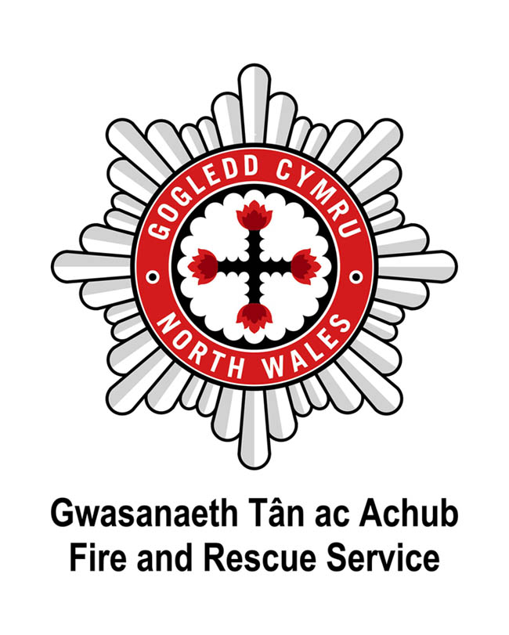


Dear Applicant

North Wales Fire and Rescue Service is an employer that is committed to equality of opportunity and welcomes applications from all sectors of the community who share our Core Values. North Wales Fire and Rescue Service have also signed the Armed Forces Covenant, which is a promise by the nation to ensure that those who serve or who have served in the armed forces, and their families, are treated fairly.

Please find enclosed the following:

- North Wales Fire and Rescue Service’s Core Values
- North Wales Fire and Rescue Service’s Welsh Language Scheme
- Guidance on completing your Application Form
- Application Form
- Equal Opportunities Monitoring Form

Should you require further information please do not hesitate to contact the Recruitment Team on 01745 535281 or email recruitment@northwalesfire.gov.wales

Please be advised that the Service is unable to issue correspondence in acknowledgment of applications, however, all applicants will be advised whether or not they have been selected for interview.

Please return completed Application Forms via email to recruitment@northwalesfire.gov.wales Applications received after the closing date will not be considered.

Please do not submit your CV with your Application Form, as only the information provided within the Application Form will be used at the interview shortlisting stage.

Applicants should be aware that social networking websites are a public forum, particularly if the applicant is part of a "network". Applicants should not assume that their entries on any website will remain private. Any messages, posts or pictures found that are deemed abusive, defamatory or in conflict with our Core Values will result in applications being withdrawn from the recruitment process.

Thank you for the interest you have shown in joining North Wales Fire and Rescue Service.

Yours sincerely

The Recruitment Team
North Wales Fire and Rescue Service

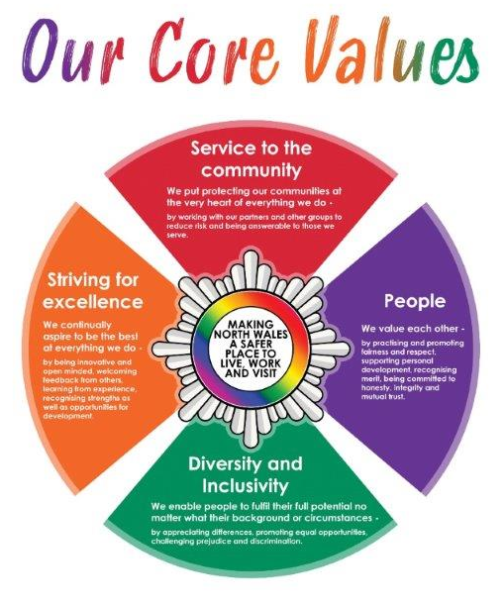

Welsh Language Scheme
At North Wales Fire and Rescue Service, we pride ourselves on having taken the issue of the Welsh language seriously over many years. By acknowledging our moral and legal duties to protect the cultural heritage of the area and to meet the expectations of the local community, we also acknowledge the positive service benefits of conducting our public business in both languages. Saving lives and reducing risk are at the heart of our mission - the language issue is vital to its success.
In accordance with statutory requirements, North Wales Fire and Rescue Service developed a Linguistic Skills Strategy to provide a means of responding appropriately to the Service's commitments contained in the Welsh Language Scheme.
As part of this Strategy, North Wales Fire and Rescue Service introduced the requirement for all new members of staff to have the ability to show basic Welsh language courtesy skills to at least Level 2. All new staff are allowed a specified period of time after formal appointment to achieve Level 2 standard.
Please note that Level 2 is the minimum requirement and that the assigned Welsh Language level for each post is listed in the Person Specification.
The Level 2 Assessment involves a short verbal test with an assessor – further help and support is available on the Welsh language pages of the North Wales Fire and Rescue Service website, where differing levels of Welsh language self-learning materials are available. This includes a number of soundbites and a practice booklet which can be used prior to the assessment. We are committed to supporting individuals as far as we can to attain the required level.
Applicants who already possess Welsh language skills or who are applying for posts with a Welsh Language requirement higher than Level 2 will be assessed against higher levels.
The demonstration of linguistic skills is also considered in the process of seeking promotion within North Wales Fire and Rescue Service.
For further information, please visit our website:
www.nwales-fireservice.org.uk/equality,-diversity-and-welsh-language-policy/welsh-language-policy.aspx?lang=en
North Wales Fire and Rescue Service welcomes communication in Welsh and English equally, and will respond without delay to correspondence or calls in both languages.
Please note which language you would prefer to receive communication in from North Wales Fire and Rescue Service: Welsh English Bilingual
Should you be shortlisted for interview, in which language would you prefer the interview to be conducted? Welsh English
If you would like to change your preference at any point please email:
recruitment@northwalesfire.gov.wales

Guidance on completing your Application Form
- Please complete all sections of the Application Form in as much detail as possible, if a section does not apply to you, please write N/A (not applicable) in the space provided.

- Use a minimum font size of 11.

- If driving is a requirement of the post (as noted in the Person Specification), you will be required to provide a unique licence check code if you are shortlisted for interview. Visit https://www.gov.uk/view-driving-licence for more information on this.

- Only applicants who meet all of the Essential Criteria (as noted in the Person Specification) will be shortlisted for interview, Desirable Criteria may be referred to in the event there are significant applicants for a vacancy. Statements of fact and or inferences can not be accepted as evidence at the shortlisting stage, therefore, please provide clear examples of relevant evidence, for example;
Essential Criteria: Knowledge and understanding of Microsoft Office Applications.
Acceptable: In my current role I am required to produce reports for the organisation on monthly expenditure. I utilise Microsoft Access to provide statistical information with the necessary formulae to calculate the subtotals and totals for each month and year end. I then present the information in a report to the Board using Microsoft Word using both text and graphs to display the numerical information.
Not Acceptable: I have knowledge and understanding of Microsoft Office applications.
- Ensure your application details why you are interested in the role and what skills and experience you can bring to the role. Skills and experience gained through employment, voluntary work or social and domestic situations are all valid. CVs attached to Application Forms will not be read or considered at the shortlisting stage.

- In line with the Service’s Core Values and in compliance with the Rehabilitation of
Offenders Act 1974 and the Safeguarding Vulnerable Groups Act 2006, the Service does not require you to disclose details of any ‘spent’ convictions, unless however, the post you are applying for involves working with vulnerable adults or children – then you must disclose all convictions, cautions, reprimands or final warnings.
All posts involving regular contact with vulnerable groups will be subject to an Enhanced Criminal Records Disclosure (unspent and spent convictions disclosed) and all other posts will require a Basic level Criminal Records Disclosure (only unspent convictions disclosed).
The Person Specification advises whether an Enhanced or Basic level Criminal Records Disclosure is required for the particular post.
To confirm if a conviction is ‘spent’ or ‘unspent’ visit www.disclosurecalculator.org.uk.
- Ensure your Application Form is returned by noon of the closing date – late applications cannot be considered.

APPLICATION FORM – STRICTLY CONFIDENTIAL Please complete in black ink or type:
Application for the post of: Watch Manager | Closing Date: noon, 11/09/2026
Surname: | Forenames(s):
Address:
Post Code: | Tel Home No:
Mobile No: | Tel No Work:
National Insurance No: | Email Address:
Do you hold a current UK driving licence? Yes No | What type of licence?
If you are successfully shortlisted for interview, and driving is a requirement of the post as indicated on the Person Specification, you will be required to provide a unique licence check code - failure to do so may result in your application failing to progress.
Are there any restrictions on your right to work in the UK? Yes No
If yes, please state restrictions and the expiry date of any permissions?

CURRENT / MOST RECENT POST
Name & Address of Employer | Position Held | Salary/Grade | Date Started | Period of Notice | Reason for Leaving
Please give brief details of your present duties/responsibilities:

PREVIOUS EMPLOYMENT (Please include any periods of unemployment)
Name & Address of Employer | Position Held | Salary | Date Started | Date To | Reason for Leaving
If you have ever been employed by North Wales Fire and Rescue Service please add your Fire Service Number here :

EDUCATIONAL AND OTHER QUALIFICATIONS (Schools/Colleges/University etc)

Name of School, College, University or Education / Training Centre | Subjects | Qualification/Examination Result | Awarding Body

CURRENT MEMBERSHIP OF PROFESSIONAL INSTITUTES / BODIES

Name of Institute | Grade / Level of Membership
EXPERIENCES/ACHIEVEMENTS

Please give details of your knowledge, skills and experience which you feel are relevant to the requirements of this post and your application. (Please attach a continuation sheet if required). It is essential that the application demonstrates that you are able to satisfy the essential requirements of the post, as detailed in the person specification - failure to do so may result in your application failing to progress.

REHABILITATION OF OFFENDERS ACT 1974 and SAFEGUARDING VULNERABLE GROUPS ACT 2006

Under the provisions of the relevant Acts and Regulations, Fire and Rescue Services now carry out a Standard DBS Check for all employees. This check will disclose both spent and unspent convictions, cautions, reprimands, and final warnings.
If the post you are applying for involves regulated activity with vulnerable adults or children, you will be required to undergo an Enhanced DBS Check, which includes all of the above information as well as any additional relevant information held by the police.
By signing this application form, you are giving your consent for the appropriate DBS check to be undertaken if your application is successful. The Person Specification for the role will indicate whether an Enhanced or Standard Level DBS Check is required.
If a positive disclosure (spent or unspent) is received, the Service will adopt a risk-based approach to manage the information and will make a reasonable and proportionate decision based on the nature of the role and the information disclosed. Further information can be found here.

Do you have any ‘unspent’ convictions? You must inform the Service if you are under investigation by the police and any ongoing actions. | Yes No
(If Yes, please give details of the offence date and the sanction imposed)

Do you have any ‘spent’ convictions, cautions, reprimands or final warnings? | Yes No
(If Yes, please give details of the offence date and the sanction imposed)

KNOWLEDGE OF LANGUAGES – Please tick where appropriate

Are you able to speak Welsh to the standard outlined within the person specification?  Are you able to speak English to the standard outlined within the person specification? | Yes No  Yes No
Are you able to read/write in Welsh to the standard outlined within the person specification?  Are you able to read/write in English to the standard outlined within the person specification? | Yes No  Yes No
Should you be shortlisted for interview, in which language would you prefer the interview to be conducted? | Welsh English
In which language would you prefer to receive communication from North Wales Fire and Rescue Service? | Welsh English Bilingual

ADDITIONAL INFORMATION

Are you personally connected to any employee of North Wales Fire & Rescue Service (examples of a personal connection include, but are not limited to, relatives, partners or friends and people you communicate with outside of employment either face to face, over the phone, or online). If so, please provide details below – please attach another sheet if required.
Name:
In what capacity are they known to you:
Have you discussed this application with them? Yes No

Have you previously had employment with another Fire and Rescue Service? Yes No
If Yes, please provide details of which FRS and role:
What was the reason that you left the Service?

A guaranteed interview will be offered to Veterans and the Spouses/Partners of Veterans and Regular serving members of the Armed Forces. This is conditional on the essential criteria of the job being met and no longer than 5 years has lapsed since leaving the Armed Forces (subject to supporting information being provided on request).
Are you or your spouse a current member of the UK Armed Forces? Yes No
If yes, please provide details:
Have you previously been a member of the UK Armed Forces? Yes No
If yes, please provide details:

Please give any dates in the near future when you will not be available for interview.

DECLARATION

Canvassing by an applicant of members of the Fire & Rescue Authority either directly or indirectly shall disqualify the candidate concerned for the appointment.
I declare that the statements given on this form are true and accurate to the best of my knowledge and belief and I am not aware of any circumstances, which if known, or become known, to the Fire & Rescue Authority might cause them to question my suitability for appointment.

Signed:  Forms received via email will not require a wet signature. | Date:

Where did you see the advertisement?

Thank you for taking the time to complete this application.

Please return completed Application Forms via email to: recruitment@northwalesfire.gov.wales

Please do not submit your CV with your Application Form, as only the information provided within the Application Form will be used at the shortlisting stage.

If you are successful we will ask you to provide professional references that cover the last five years of employment. One reference must be your immediate supervisor from your most recent employer.

All applicants are also required to declare any previous Fire and Rescue Service employment history, as North Wales Fire and Rescue Service (NWFRS) will seek an employment reference from them as part of its pre-employment checks.

Applications received after the closing date will not be considered.

EQUALITIES MONITORING FORM

As a public authority North Wales Fire and Rescue Service is required to take steps and aims to promote equality of opportunity and combat discrimination. This information does not form any part of your application and is removed from your application form before submission to the short-listing stage. The information gathered will be used for monitoring, and informing positive action initiatives.
Name: |  | Date of Birth:

Ethnicity
White (British/Welsh/Scottish/Irish) |  | White Other
Black/African/Caribbean/Black British |  | Dual Heritage/multiple ethnic backgrounds
Asian/Asian British |  | Any other Ethnic Group
Other, please specify:

Sex
What is your sex: |  | Male |  | Female |  |  |  | Intersex
Transgender: (Is your gender different from birth?) |  | Yes |  | No |  | Do not wish to state
Sexual Orientation: |  | Heterosexual/straight |  |  |  | Gay
Lesbian |  | Bisexual |  |  |  | Asexual
Pansexual |  | Other |  |  |  | Do not wish to state

Marriage or Civil Partnership
Married |  | Living with a partner
Civil Partnership |  | Single
Widowed |  | Separated
Divorced |  | Do not wish to state

Religion or Belief
No Religion or belief |  | Christian
Buddhist |  | Hindu
Jewish |  | Sikh
Muslim |  | Do not wish to state
Other religion or belief, please specify:

Maternity
Are you currently pregnant, or currently on maternity leave? | Yes |  | No |  | Prefer not to say

Welsh Language Status?
Fluent |  | Intermediate
Learning |  | Cannot speak Welsh at all

EMPLOYEE HEALTH, ACCESSIBILITY AND SUPPORT FORM

We want to ensure every member of staff is well supported at work. If you have a disability or long-term health condition, you can tell us by selecting the category below that best describes your circumstances.

A disability is any physical, mental, or neurodiverse impairment that has a substantial and long-term effect on your ability to carry out normal day-to-day activities — for example, something that affects mobility, sight, hearing, learning, concentration, communication, energy levels, or mental wellbeing.

If you are successful at shortlist and invited for interview or assessments, you will be given the opportunity to request reasonable adjustments. Reasonable adjustments are small changes we can make to help you feel supported and able to do your best in the recruitment process.

The information you provide does not form part of your application and will be held securely in line with UK GDPR and our confidentiality policies.

Disability and Impairment Categories (Please select one or more)

No disability

Prefer not to say

Physical Impairment
Impairments affecting mobility, dexterity, stamina or physical functioning.
Examples: arthritis, orthopaedic conditions, chronic pain, paralysis.

Sensory Impairment
Impairments affecting sight, hearing or other senses.
Examples: blindness, low vision, deafness, tinnitus.

Learning Disability / Specific Learning Difficulty
Conditions affecting learning, processing or understanding.
Examples: learning disability, dyslexia, dyscalculia, dysgraphia.

Neurodevelopmental Condition
Conditions affecting brain development or neurocognitive functioning.
Examples: autism, ADHD.

Mental Health Condition
Long-term conditions affecting thinking, mood, or behaviour.
Examples: depression, anxiety, bipolar disorder, schizophrenia.

Progressive Condition
Conditions that worsen over time.
Examples: multiple sclerosis, Parkinson’s, motor neurone, and Huntington’s disease.

Fluctuating or Recurring Condition (substantial symptoms/long-term affect day-to-day activities)
Conditions with variable symptoms over time.
Examples: fibromyalgia, endometriosis, rheumatoid arthritis.

Long-Term Medical Condition / Chronic Illness
Ongoing conditions not captured above.
Examples: diabetes, epilepsy, heart disease, chronic fatigue syndrome, cancer.

Other Disability or Long-Term Condition
(Please specify):

