**NORTH WALES**

**FIRE AND RESCUE SERVICE**

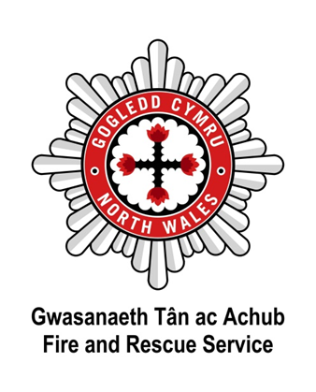

**PERFORMANCE MONITORING REPORT**

**For the twelve months**

**April 2022 – March 2023**

**Figures are provisional and may be subject to minor amendment.**

**CONTENTS**

|  |  |
| --- | --- |
| **INCIDENT ACTIVITY REPORTING** |  |
|  |  |
| **ALL INCIDENTS** |  |
| All Incidents | 1-2 |
|  |  |
| **FIRES BY CATEGORY** |  |
| Fires by category and motive | 3-4 |
| Primary Fires, by property type and motive | 5 |
| Accidental fires in dwellings | 6-7 |
| Fatalities and casualties from accidental fires in dwellings | 8 |
| Smoke Detectors - Accidental Dwelling Fires (ADFs) | 9-10 |
|  |  |
| **FALSE ALARMS** |  |
| False alarms by category | 11-12 |
|  |  |
| **SPECIAL SERVICE INCIDENTS** | |
| Special service incidents by category | 13-14 |
| Road Traffic Collisions and Extrications/Release | 15-16 |
|  |  |
| **MONITORING AGAINST OBJECTIVE 1- TO WORK TOWARDS MAKING IMPROVEMENTS TO THE HEALTH, SAFETY AND WELL-BEING OF PEOPLE IN WALES** | |
| Safe and Well Checks | 17-18 |
| Planned 20 Station Availability | 19 |
|  |  |
| **GLOSSARY** |  |
| Glossary | 20-21 |

1. During the 2022/23 financial year, the Service attended 5,896 emergency incidents and false alarms, a 10.1% increase on the previous financial year (5,355).

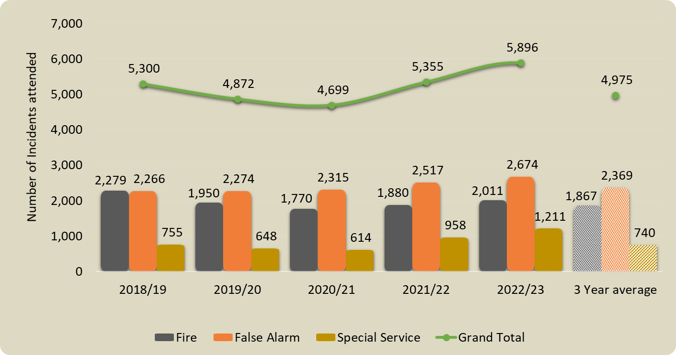

|  |  |  |  |  |  |  |  |  |  |  |
| --- | --- | --- | --- | --- | --- | --- | --- | --- | --- | --- |
| **Category** | **Year** | **Q1** | **Q2** | **Q3** | **Q4** | **Year- to-Date**  **(YTD)** | **% change YTD** |  | **Average of 3 previous years** | **% change YTD / Average of 3 previous years** |
|  | | | | | | | |  |  | |
| Total incidents attended | **2022-23** | **1,575** | **1,878** | **1,211** | **1,232** | **5,896** | ⬆  10.1% |  | 4,975 | ⬆  18.5% |
| 2021-22 | 1,322 | 1,415 | 1,254 | 1,364 | 5,355 |  |
|  |  |  |  |  |  |  |  |  |  |  |
| Total fires | **2022-23** | **577** | **719** | **337** | **378** | **2,011** | ⬆  7.0% |  | 1,867 | ⬆  7.7% |
| 2021-22 | 575 | 480 | 347 | 478 | 1,880 |  |
|  |  |  |  |  |  |  |  |  |  |  |
| Total special service incidents | **2022-23** | **327** | **371** | **267** | **246** | **1,211** | ⬆  26.4% |  | 740 | ⬆  63.6% |
| 2021-22 | 152 | 233 | 315 | 258 | 958 |  |
|  | | | | | | | | | | |
| Total false alarms | **2022-23** | **671** | **788** | **607** | **608** | **2,674** | ⬆  6.2% |  | 2,369 | ⬆  12.9% |
| 2021-22 | 595 | 702 | 592 | 628 | 2,517 |  |
| *The final two columns show: the average of the 3-previous financial years (based on the equivalent reporting period); the percentage change based on the difference between the current financial year and the 3-year average. | | | | | | | | | | |

**Narrative**

**Fires increase** – The 7.0% increase in fires (from 1,880 to 2,011) can be attributed to the hot summer the UK and Wales was subject to, thus showing an increase of 144 incidents, a 7.7% increase over the 3-year average of 1,867.

**AFAs** **(non-domestic)** **increase** – We are aware of the increase in AFAs in non-domestic settings. These calls are predominately from BCUHB (numerous activation reasons). We continue to work with BCUHB in reducing these AFA activations. There is also an increase in domestic (dwelling) attendance to AFAs and this is referred to later in this report.

**SSCs increase** – The overall increase is due to a change in organisational policy in relation to attending SSCs; making crew more visible in the community.

# 2 Fires, by Category and Motive

* 1. A total of 2,011 fires were attended; a 7.0% increase from 1,880 in 2021/22.
  2. **Primary fires –** There was a 3.1% decrease in primary fires, from 881 to 854 compared with the previous financial year and were 3.4% below the 3‑year average of 884.
  3. **Secondary fires –** There was an 18.0% increase in secondary fires, from 879 to 1,037, and were 23.2% above the 3-year average of 842.
  4. **Chimney fires –** The number of chimney fires remained unchanged at 120, the same as during the previous financial year, and were 14.9% below the 3‑year average of 141.

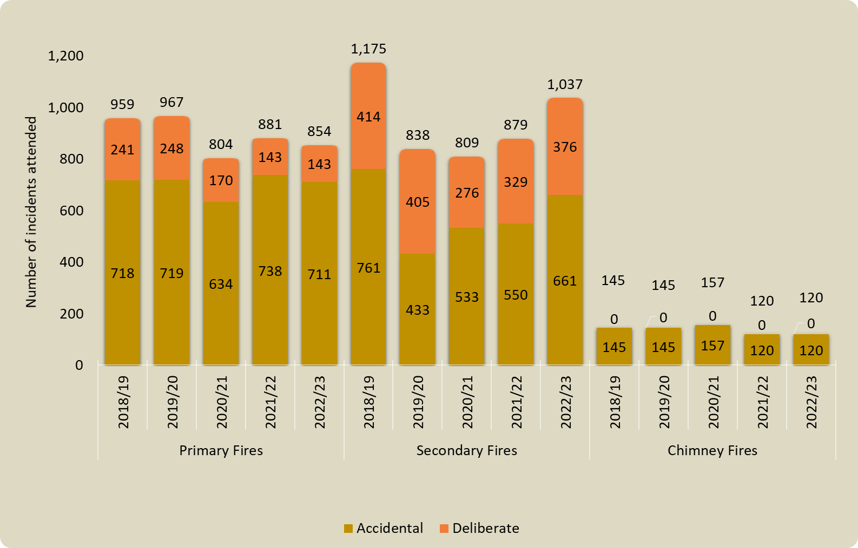

|  |  |  |  |  |  |  |  |  |  |  |  |
| --- | --- | --- | --- | --- | --- | --- | --- | --- | --- | --- | --- |
| **Category** | **Year** | **Q1** | **Q2** | **Q3** | **Q4** | **Year- to-Date**  **(YTD)** | **% change YTD** |  | **Average of 3 previous years** | **% change YTD / Average of 3 previous years** | |
|  |  |  |  |  |  |  |  |  |  | |  |
| Primary fires | **2022-23** | **226** | **236** | **193** | **199** | **854** | ⬇  3.1% |  | 884 | | ⬇  3.4% |
| 2021-22 | 251 | 229 | 200 | 201 | 881 |  |
|  |  |  |  |  |  |  |  |  |  | |  |
| Secondary fires | **2022-23** | **332** | **476** | **100** | **129** | **1,037** | ⬆  18.0% |  | 842 | | ⬆  23.2% |
| 2021-22 | 293 | 244 | 110 | 232 | 879 |  |
|  |  |  |  |  |  |  |  |  |  | |  |
| Chimney fires | **2022-23** | **19** | **7** | **44** | **50** | **120** | ➔  0.0% |  | 141 | | ⬇  14.9% |
| 2021-22 | 31 | 7 | 37 | 45 | 120 |  |
| *The final two columns show: the average of the 3 previous financial years (based on the equivalent reporting period); the percentage change based on the difference between the current financial year and the 3-year average. | | | | | | | | | | | |

**Narrative**

There was a year-on-year reduction in accidental primary fires. The reduction has been attributed to our ongoing prevention activities which are delivered during SAWCs and other engagements with the public.

The increase in both secondary accidental (from 550 to 661) and secondary deliberate (from 329 to 376) fires is attributed to the hot summer in the UK. In comparison, 2018/19 was also a very hot and dry summer in North Wales. Chimney Fires increased by 6 between Q3 and Q4 of the financial year. This is not unexpected following increases in utility fuel prices and the increased use of open and wood burning fires. NWFRS has been working with Scottish Power (SP) and other agencies regarding the provision of ‘winter packs’ to residents.

**Actions taken to support communities and reduce fire events:**

* 18,052 SAWCs have been delivered across North Wales in line with our current strategy;
* Work with strategic partners has continued, identifying potential risks to reduce deliberate fire incidents;
* Deliberate fire setting intervention schemes have been facilitated in-house and by DangerPoint;
* New Wales Wildfire Board has been established and the All Wales Wildfire Charter drafted to support the reduction in accidental and deliberate secondary fires;
* Prevention teams proactively attended farmers markets and agricultural shows including RWAS in July 2022 to raise the profile of impacts of Wildfires in North Wales;
* Campaign Steering Group (CSG) continued to work with Corporate Communications to proactively promote safety and Wildfire messaging across all media platforms;
* There was significant involvement with community Bonfire and Fireworks events across the service area.

# 3 Primary Fires, by Property Type and Motive

* 1. During the financial year, 48 primary fires were started deliberately at non-residential buildings, compared with 54 during 2021/22.
  2. There were 19 deliberate fires at HMP Berwyn, compared with 22 in the previous financial year.

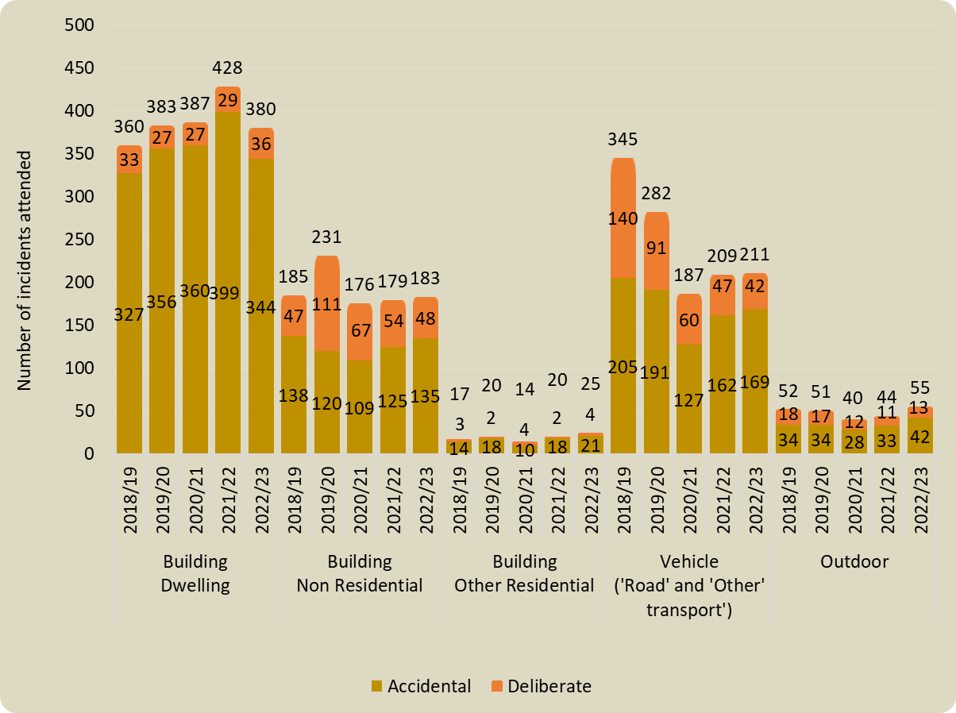

|  |  |  |  |  |  |  |  |  |  |  |
| --- | --- | --- | --- | --- | --- | --- | --- | --- | --- | --- |
| **Category** | **Year** | **Q1** | **Q2** | **Q3** | **Q4** | **Year- to-Date**  **(YTD)** | **% change YTD** |  | **Average of 3 previous years** | **% change YTD / Average of 3 previous years** |
|  | | | | | | | |  |  | |
| All deliberate primary fires | **2022-23** | **41** | **49** | **24** | **29** | **143** | ➔  0.0% |  | 187 | ⬇  23.5% |
| 2021-22 | 40 | 42 | 31 | 30 | 143 |  |
|  |  |  |  |  |  |  |  |  |  |  |
| All accidental primary fires | **2022-23** | **185** | **187** | **169** | **170** | **711** | ⬇  3.5% |  | 697 | ⬆  2.0% |
| 2021-22 | 211 | 187 | 169 | 171 | 737 |  |
| *The final two columns show: the average of the 3 previous financial years (based on the equivalent reporting period); the percentage change based on the difference between the current financial year and the 3-year average. | | | | | | | | | | |

**

# 4 Accidental fires in dwellings

1. The Service attended 344 accidental dwelling fires during the reporting period, 55 (14.0%) less than during the previous financial year (400), and 7.5% below the 3-year average of 372.

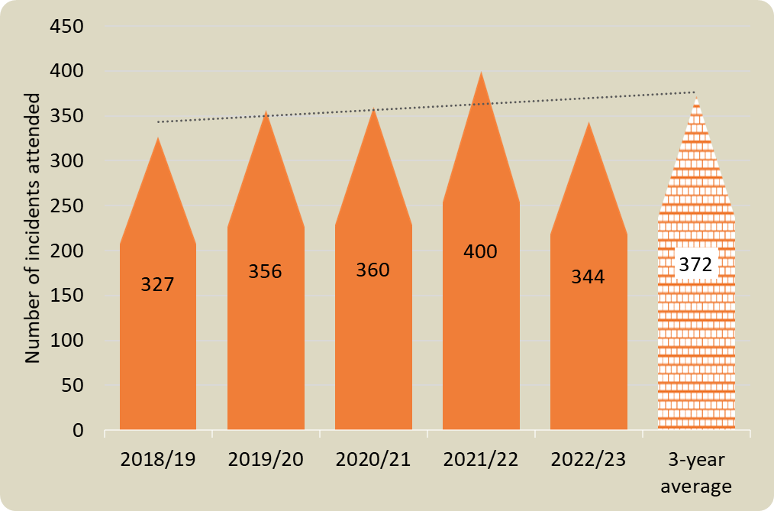

|  |  |  |  |  |  |  |  |  |  |  |
| --- | --- | --- | --- | --- | --- | --- | --- | --- | --- | --- |
| **Category** | **Year** | **Q1** | **Q2** | **Q3** | **Q4** | **Year- to-Date**  **(YTD)** | **% change YTD** |  | **Average of 3 previous years** | **% change YTD / Average of 3 previous years** |
|  | | | | | | | |  |  | |
| Accidental fires in dwellings | **2022-23** | **81** | **81** | **97** | **85** | **344** | ⬇  14.0% |  | 372 | ⬇  7.5% |
| 2021-22 | 113 | 95 | 106 | 86 | 400 |  |
| *The final two columns show: the average of the 3 previous financial years (based on the equivalent reporting period); the percentage change based on the difference between the current financial year and the 3-year average. | | | | | | | | | | |

**Narrative**

* There was a 14.0% reduction in the number of ADFs (344 from 400) and were 7.5% lower than the 3-year average of 372.

**Actions taken to support communities and reduce ADFs:**

* Ongoing work with regional hoarding groups to identify people at risk;
* Referrals continue to be received from partner agencies, totalling 31.8% (5,733) of all SAWCs delivered;
* Partnership Managers have explored new relationships with external partners to identify those persons most vulnerable to fire;
* A joint venture between NWFRS, Bangor University, and Catrefi Conwy was undertaken where StoveGuards were fitted in student accommodation to reduce cooker fires;
* Station Open days were reinvigorated which generated SAWCs and gave extra opportunity to provide safety advice;
* Local and national (Wales & NFCC) campaigns have been supported in line with our own Campaign Steering Group (CSG) calendar;
* Locally run and targeted outreach days have continued to be supported by external agencies. Areas are leafleted by Prevention teams who then return to provide SAWCs (Crews and HSSWs);
* Cost of Living ‘drop in’ campaign took place in Rhyl providing Prevention teams with the opportunity to give further safety advice;
* Proactive hot spotting campaigns following significant incidents produced SAWC referrals and community reassurance following incidents;
* Partnership between NWFRS and Cartrefi Conwy and Care & Repair continued to identify high priority referrals – we engage with vulnerable people who are discharged from hospital/care settings to provide interventions where required;
* Christmas safety activity included supporting local foodbanks and delivering safety talks to Ukrainian refugees.

# 5 Fatalities and casualties from accidental fires in dwellings

1. There were no ADF fatalities during the 2022/23 financial year, compared with 5 during the previous financial year. There were 3 serious, and 23 slight injuries, compared with 5 and 34 respectively. The number of precautionary checks decreased from 31 to 20, whilst the number of people requiring first aid at the scene also decreased from 43 to 25.

|  |  |  |  |  |  |
| --- | --- | --- | --- | --- | --- |
| **Severity of injury** | **2018/19** | **2019/20** | **2020/21** | **2021/22** | **2022/23** |
| Precautionary Check | 13 | 19 | 33 | 31 | 20 |
| First Aid | 27 | 41 | 26 | 43 | 25 |
| Injuries - Slight | 11 | 26 | 29 | 34 | 23 |
| Injuries - Serious | 6 | 4 | 3 | 5 | 3 |
| Fatality | 5 | 3 | 5 | 5 | 0 |
| Total | 62 | 93 | 96 | 118 | 71 |

|  |  |  |  |  |  |  |  |  |  |  |
| --- | --- | --- | --- | --- | --- | --- | --- | --- | --- | --- |
| **Category** | **Year** | **Q1** | **Q2** | **Q3** | **Q4** | **Year- to-Date**  **(YTD)** | **%**  **change YTD** |  | **Average of 3 previous years** | **Change YTD / Average of 3 previous years** |
|  | | | | | | | |  |  | |
| Injuries from accidental fires in dwellings | **2022-23** | **10** | **37** | **14** | **10** | **71** | ⬇  37.2% |  | 98 | ⬇  27.6% |
| 2021-22 | 43 | 23 | 30 | 17 | 113 |  |
|  |  |  |  |  |  |  |  |  |  |  |
| Deaths from accidental fires in dwellings | **2022-23** | **0** | **0** | **0** | **0** | **0** | ⬇  100% |  |  |  |
| 2021-22 | 3 | 0 | 0 | 2 | 5 |  |

# 6 Smoke Detectors – Accidental Dwelling Fires (ADFs)

1. Smoke/heat detectors were present at the majority of ADFs, although not all went on to operate. At 44 of the ADFs, no detector was fitted. 
   1. Of the 344 ADFs, 301 were confined to the room of origin, the item first ignited, or there was heat/smoke damage only.

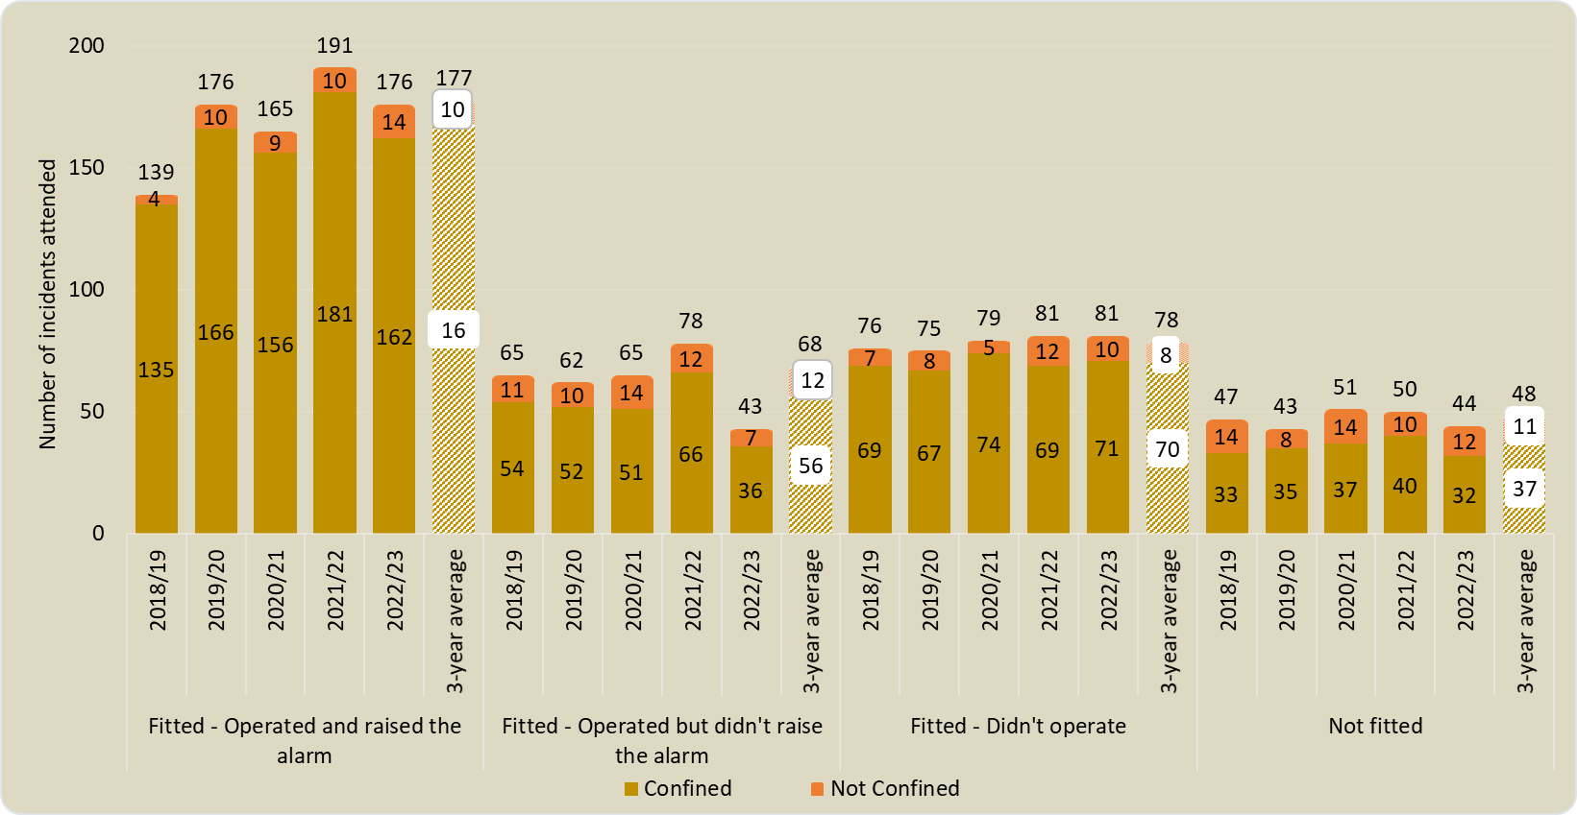

|  |  |  |  |  |  |  |  |  |  |  |
| --- | --- | --- | --- | --- | --- | --- | --- | --- | --- | --- |
| **Category** | **Year** | **Q1** | **Q2** | **Q3** | **Q4** | **Year- to-Date**  **(YTD)** | **% change YTD** |  | **Average of 3 previous years** | **% change YTD / Average of 3 previous years** |
|  | | | | | | | |  |  | |
| Smoke detector fitted which operated and raised alarm | **2022-23** | **36** | **45** | **49** | **46** | **176** | ⬇  7.9% |  | 177 | ⬇  0.6% |
| 2021-22 | 54 | 46 | 55 | 36 | 191 |  |
|  |  |  |  |  |  |  |  |  |  |  |
| Smoke detector fitted which operated but didn’t raise the alarm | **2022-23** | **17** | **4** | **10** | **12** | **43** | ⬇  44.9% |  | 69 | ⬇  37.7% |
| 2021-22 | 20 | 20 | 16 | 22 | 78 |  |
|  |  |  |  |  |  |  |  |  |  |  |
| Smoke detector didn’t operate | **2022-23** | **22** | **19** | **25** | **15** | **81** | ➔  0.0% |  | 78 | ⬆  3.8% |
| 2021-22 | 26 | 16 | 21 | 18 | 81 |  |
|  |  |  |  |  |  |  |  |  |  |  |
| Smoke detector not fitted | **2022-23** | **6** | **13** | **13** | **12** | **44** | ⬇  12.0% |  | 48 | ⬇  8.3% |
| 2021-22 | 13 | 13 | 14 | 10 | 50 |  |
| *The final two columns show: the average of the 3 previous financial years (based on the equivalent reporting period); the percentage change based on the difference between the current financial year and the 3-year average. | | | | | | | | | | |

**Actions taken to support communities by increasing smoke alarm ownership and safety education:**

* The Service aimed to deliver 20,000 SAWCs during the financial year; 18,052 were achieved. The target for 23/24 will be 17,500;
* Continued to work with partners to identify the most vulnerable people in our communities and provide them with suitable advice and interventions;
* Education and awareness of the correct siting and fitting of smoke alarms in people’s homes to prevent unnecessary activations and false alarms also continued;
* NWFRS has continued to promote regular testing of smoke alarms using all media platforms;
* Endeavours continued to ensure our advice provided details and actions to be taken if a fire starts or a smoke alarm activates in the home;
* Educationalists continued to promote smoke alarm ownership and testing as part of the delivery across North Wales schools.

# 7 False Alarms

* 1. In the 2022/23 financial year, there were 2,674 false alarms; a 6.2% increase from 2,517 in the previous financial year. There was a 9.6% increase in AFAs from 1,398 to 1,532. False alarms made with good intent increased slightly, from 1,076 to 1,090.

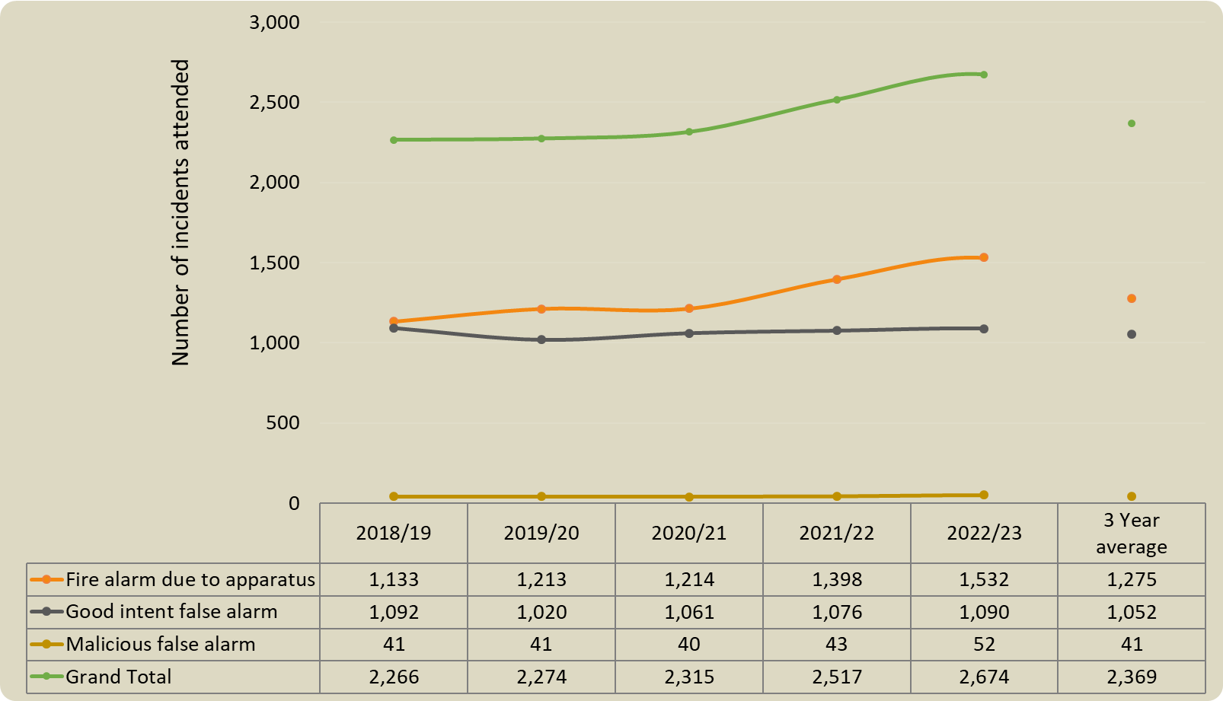

|  |  |  |  |  |  |  |  |  |  |  |  |  |  |  |  |  |  |
| --- | --- | --- | --- | --- | --- | --- | --- | --- | --- | --- | --- | --- | --- | --- | --- | --- | --- |
| **Category** | **Year** | **Q1** | **Q2** | | **Q3** | | **Q4** | | **Year- to-Date**  **(YTD)** | | **% change YTD** | |  | | **Average of 3 previous years** | | **% change YTD / Average of 3 previous years** |
|  |  | | | | | | | | | | | | | | |  |  |
| Total false alarm | **2022-23** | **671** | **788** | | **607** | | **608** | | **2,674** | | ⬆  6.2% | |  | | 2,369 | | ⬆  12.9% |
| 2021-22 | 595 | 702 | | 592 | | 628 | | 2,517 | |  | |
|  |  |  | |  | |  | |  | |  | |  | |  | |  |  |  |
| AFA | **2022-23** | **416** | **420** | | **360** | | **337** | | **1,532** | | ⬆  9.6% | |  | | 1,275 | | ⬆  20.2% |
| 2021-22 | 311 | 403 | | 345 | | 339 | | 1,398 | |  | |
|  |  |  | |  | |  | |  | |  | |  | |  | |  |  |  |
| False alarms made with good intent | **2022-23** | **241** | **353** | | **238** | | **258** | | **1,090** | | ⬆  1.3% | |  | | 1,052 | | ⬆  3.6% |
| 2021-22 | 278 | 287 | | 235 | | 276 | | 1,076 | |  | |
|  |  |  | |  | |  | |  | |  | |  | |  | |  |  |  |
| Malicious | **2022-23** | **14** | **15** | | **9** | | **14** | | **52** | | ⬆  20.9% | |  | | 41 | | ⬆  26.8% |
| 2021-22 | 6 | 12 | | 12 | | 13 | | 43 | |  | |
| *The final two columns show: the average of the 3 previous financial years (based on the equivalent reporting period); the percentage change based on the difference between the current financial year and the 3-year average. | | | | | | | | | | | | | | | | | |

**Narrative**

* **2,676** Total False Alarms attended (increase of 6.2%);
* **1,532** Total Fire alarm due to apparatus (AFA) (increase of 9.6%);
* Fire alarm due to ‘apparatus’ represented 57.3% of total False Alarms.

**What we have done:**

* **AFAs in dwellings** –The Service conducted a targeted approach to fire prevention during the financial year to keep the most vulnerable people safe in our communities, which included working with care providers by installing care line systems (this may increase the number of AFAs we attend in dwellings, but each attendance will give us an opportunity to provide further, often bespoke safety advice). We will continue to monitor AFAs in dwellings next year by:
  + Continuing to review the daily incident log by Partnership Managers in the areas to spot any emerging trends and/or repeat calls to the same premises;
  + Continuing to work with care line providers ensuring call monitoring staff have the appropriate training and review if required e.g. new starters;
  + Continuing to provide safety advice when NWFRS attend AFAs in dwellings;
  + Continuing to make referrals to external agencies when further specialist support is identified and needed.
* **AFAs in non-residential** -We have worked with BCUHB to try and reduce the number of actuations, and support BCUHB’s plan to reduce AFAs in the future, which we will continue to monitor during the coming year;
* **AFAs in ‘other residential’** - As above, work is ongoing to support BCUHB to reduce AFA activations in care settings. We are also working with higher education establishments to reduce AFAs through targeted Prevention campaigns.

# 8 Special Service Incidents

1. Special service calls increased 26.4% to 1,211 during the 2022/23 financial year, compared with 958 in 2021/22. Road traffic collisions increased 13.0% from 207 to 234, whilst ‘Other than RTC’ incidents increased 30.1%, from 751 to 977. (The rise in SSCs attended was expected following the Service’s decision to increase visability in the community).

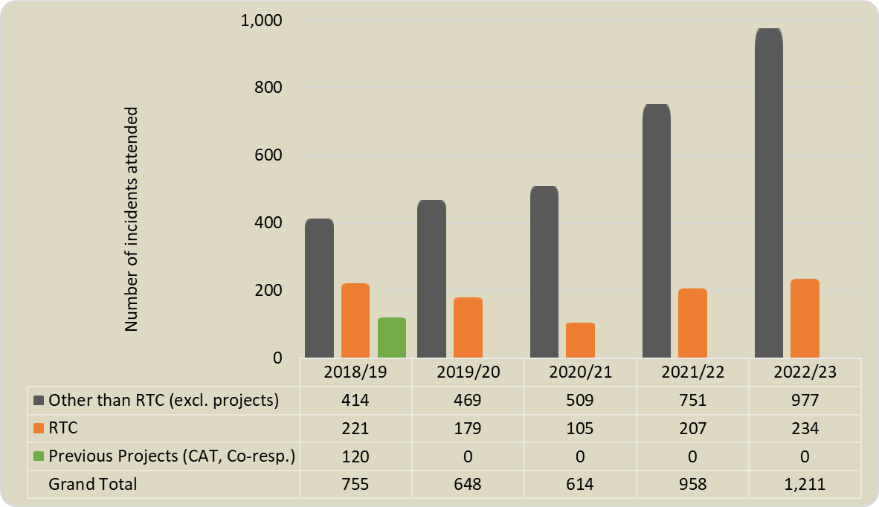

|  |  |  |  |  |  |  |  |  |  |  |
| --- | --- | --- | --- | --- | --- | --- | --- | --- | --- | --- |
| **Category** | **Year** | **Q1** | **Q2** | **Q3** | **Q4** | **Year- to-Date**  **(YTD)** | **% change YTD** |  | **Average of 3 previous years** | **% change YTD / Average of 3 previous years** |
|  | | | | | | | |  |  | |
| Total special service calls | **2022-23** | **327** | **371** | **267** | **246** | **1,211** | ⬆  26.4% |  | 740 | ⬆  63.6% |
| 2021-22 | 152 | 233 | 315 | 258 | 958 |  |
|  | | | | | | | | | | |
| Road traffic collisions (RTC) | **2022-23** | **53** | **65** | **60** | **56** | **234** | ⬆  13.0% |  | 164 | ⬆  42.7% |
| 2021-22 | 31 | 56 | 68 | 52 | 207 |  |
|  |  |  |  |  |  |  |  |  |  |  |
| Other than RTC | **2022-23** | **274** | **306** | **207** | **190** | **977** | ⬆  30.1% |  | 576 | ⬆  69.6% |
| 2021-22 | 121 | 177 | 247 | 206 | 751 |  |
| *The final two columns show: the average of the 3 previous financial years (based on the equivalent reporting period); the percentage change based on the difference between the current financial year and the 3-year average. | | | | | | | | | | |

**Narrative**

**1,211** special service calls attended (26.4% increase);

**977** Other than RTC (excl. projects) (increase of 30.1%).

* The reason for NWFRS’s increased attendance to SSCs is a result of a conscious decision taken by the organisation to change the approach and be more proactive in responding to requests for assistance which would not typically require a Fire and Rescue Service response. This has resulted in being more visible in the community.
* The number of RTCs attended increased to 234 and were higher than the 3‑year average of 164. It should be noted that the number of visitors to the area, especially during the summer months, was significant during 2022 (release from all Covid-19 restrictions).
* ‘Olivia’s Story’ continued to be delivered in collaboration with NWP. Over 2,500 young people have now been given the presentation.
* NWFRS is a stakeholder and key participant of the North Wales Road Safety Group, supporting the delivery of interventions where required.

# 9 Road Traffic Collisions and Extrications/Release

* 1. Out of the 234 road traffic collisions attended in the 2022/23 financial year, 69 (29.6%) involved the Service using equipment to extricate at least one casualty from the vehicle. Whilst 129 incidents resulted in injuries, the majority of casualties sustained only slight injuries.

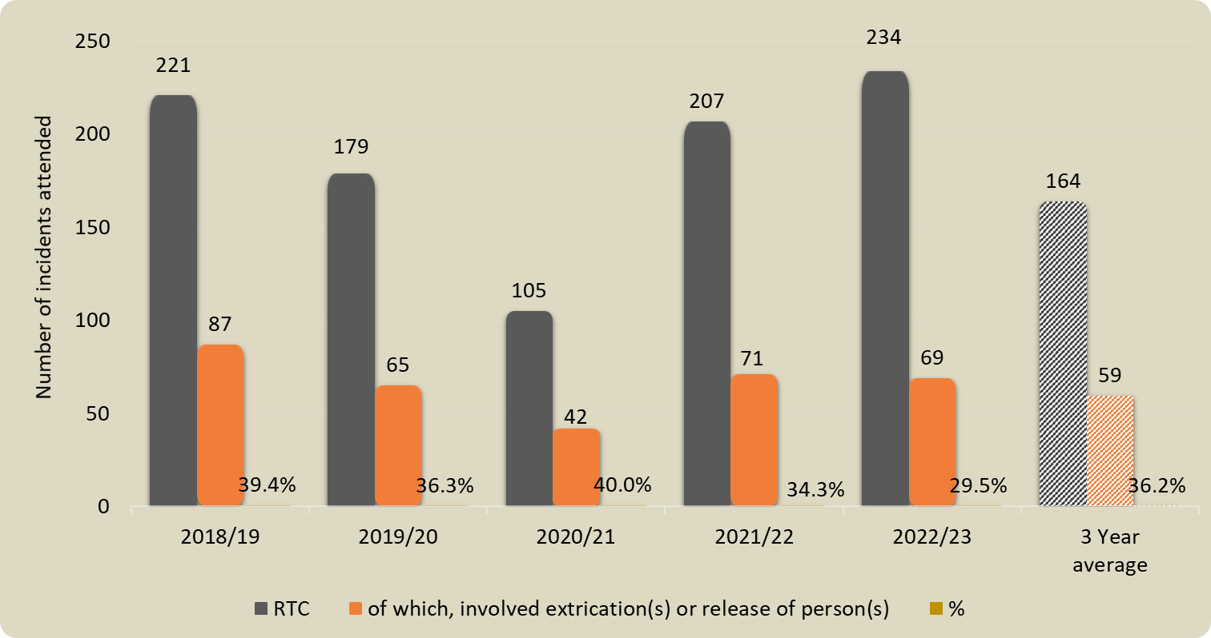

|  |  |  |  |  |
| --- | --- | --- | --- | --- |
| **234** | RTC incidents attended |  | **Severity of Injury \*** | **Number of people** |
| **129** | incidents where people sustained injury |  | Precautionary check | 49 |
| **69** | incidents involved extrication / release |  | First Aid | 31 |
|  |  |  | Injuries - Slight | 87 |
|  |  |  | Injuries - Serious | 58 |
|  |  |  | Fatalities | 9 |
|  |  |  | *\*RTC injuries - where available are recorded in the IRS in the same categorisation as fire injuries* | |

**Narrative**

**234** RTCs attended, a 13.0% increase from 207;

**69** (29.6%) involved extrication / release of persons.

Despite the increase in RTCs attended, there was a reduction in the percentage of extrications required by NWFRS crews. The increase in visitor numbers (road traffic) in North Wales during the summer of 2022 was the likely reason for the increase of RTCs.

**Action taken to reduce the number of road traffic collision:**

* ‘Olivia’s Story’ was delivered in collaboration with NWP. Over 2,500 young people have now been given the presentation;
* NWFRS Prevention staff continued to attend the North Wales Road Safety Group;
* NWFRS, in partnership with WAST and NWP, remains part of the ‘Deadly Impacts’ intervention that details the consequences of a road traffic collision (RTC) (death and serious injuries).

# 10 Monitoring against Improvement and Well-being objective 1:

1.1*To support people to prevent accidental dwelling fires and stay safe if they do occur.*

1.  **Safe and Well Checks**

The Service completed 18,052 Safe and Well Checks during 2022/23, of which 5,733 (31.8%) were undertaken in response to a referral from a partner agency.

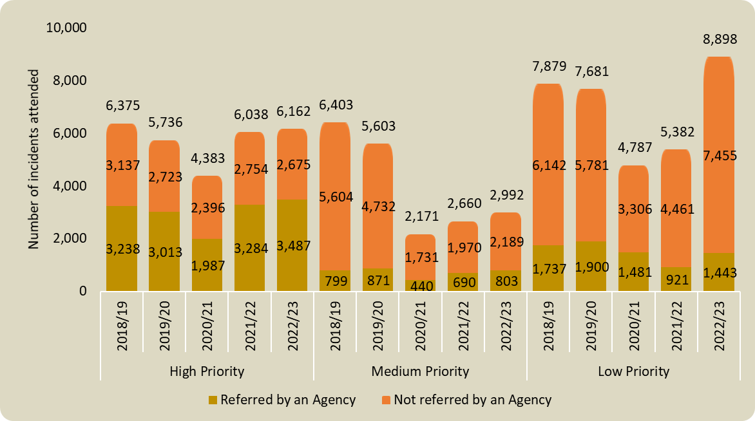

|  |  |  |  |  |  |  |  |  |  |  |
| --- | --- | --- | --- | --- | --- | --- | --- | --- | --- | --- |
| **Category** | **Year** | **Q1** | **Q2** | **Q3** | **Q4** | **Year- to-Date**  **(YTD)** | **Change YTD** |  | **Average of 3 previous years** | **Change YTD / Average of 3 previous years** |
|  | | | | | | | |  |  | |
| % of all Safe and Well Checks undertaken that originated from a referral from a partner organisation | **2022-23** | **35.2%** | **30.2%** | **31.7%** | **30.1%** | **31.8%** | ⬇  8.4% |  | 32.9% | ⬇  3.3% |
| 2021-22 | 39.5% | 34.5% | 34.6% | 32.1% | 34.7% |  |
| *The final two columns show: the average of the 3 previous financial years (based on the equivalent reporting period); the percentage change based on the difference between the current financial year and the 3-year average. | | | | | | | | | | |

**Narrative**

**18,052** SAWCs completed of which: -

**6,162** (34.1%) referrals were high priority, with 3,487 coming from a partner agency;

**2,992** (16.6%) were Medium Priority SAWCs;

**8,898** (49.3%) were Low Priority SAWCs.

**Action taken to improve performance & comments:**

* The target of 20,000 SAWCs was not achieved. However, given the unprecedented financial pressures the Service now finds itself under, the Fire Safety department has seen a reduction of 2.5 Home Safety Support Worker (HSSW) posts (approved 16th January 2023 FA meeting), a long term HSSW vacant post not filled, and some periods of sickness absence. These have unfortunately had a negative impact;
* There was a return to pre Covid-19 SAWC activity following positive re-engagement work with our partner agencies;
* SAWCs were delivered as previously referred to in the report, including via telephone, where appropriate;
* Prevention campaigns and safety advice in line with our CSG and Corporate Communications campaign calendar continued;
* Re-engagement of the previous High priority project continued and involved all WT, DC, and WDSR crews;
* Bespoke interventions continued to be provided to the most vulnerable in the community;
* The array of interventions issued to occupiers continued to grow, including innovative equipment such as Stoveguards;
* SAWC targets to increase for all Day Crewed and Wholetime watches (12 to 15/shift) from 1st April 2023.

# 11 Planned 20 Stations Availibility

1. NWFRS has 44 fire stations with 54 response pumps, as 8 stations have 2 pumps and Wrexham has 3.  Pre-planning takes place each day to deploy resources to ensure 20 are made available between 0600 and 1800.  Short notice changes can sometimes result in a reduction that cannot be immediately rectified.

During 2022/23, the number of times the threshold of 20 was met increased 3.5% to 324 days (88.8%) compared with 313 days (85.8%) in 2021/22. From 1st April 2023, the Fire Authority has agreed the minimum will be 18.

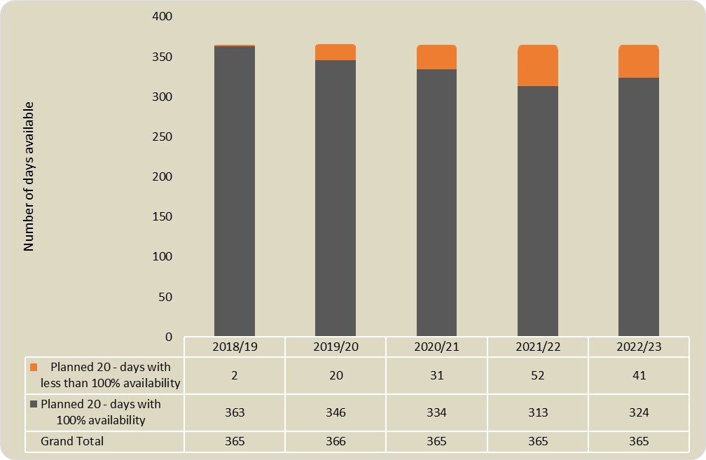

## Glossary

|  |  |
| --- | --- |
| Fires | All fires fall into one of three categories – primary, secondary or chimney. |
| Primary Fires | These are fires that are not chimney fires, and which are in any type of building (except if derelict), vehicles, caravans and trailers, outdoor storage, plant and machinery, agricultural and forestry property, and other outdoor structures such as bridges, post boxes, tunnels, etc.  Fires in any location are categorised as primary fires if they involved casualties, rescues or escapes, as are fires in any location that were attended by five or more fire appliances. |
| Secondary Fires | Secondary fires are fires that are neither chimney fires nor primary fires.  Secondary fires do not involve casualties, rescues or escapes, and will have been attended by four or fewer fire appliances.  Secondary fires are those that would normally occur in locations such as open land, in single trees, fences, telegraph poles, refuse and refuse containers (but not paper banks, which would be considered - in the same way as agricultural and forestry property - to be primary fires), outdoor furniture, traffic lights, etc. |
| Chimney Fires | These are fires in occupied buildings where the fire is confined within the chimney structure, even if heat or smoke damage extends beyond the chimney itself.  Chimney fires do not involve casualties, rescues or escapes, and will have been attended by four or fewer fire appliances. |
| Special Service Incidents | These are non-fire incidents which require the attendance of an appliance or officer and include:   1. Local emergencies e.g., flooding, road traffic incidents, rescue of persons, 'making safe' etc; 2. Major disasters; 3. Domestic incidents e.g., water leaks, persons locked in or out etc; 4. Prior arrangements to attend incidents, which may include some provision of advice and inspections. |
| False Alarm (general guidance) | Where the FRS attends a location believing there to be an incident, but on arrival discovers that no such incident exists, or existed.  Note: if the appliance is ‘turned around’ by Control before arriving at the incident it is not classed as having been attended and does not need to be reported. |
| False Alarms - Malicious | These are calls made with the intention of getting the FRS to attend a non-existent incident, including deliberate and suspected malicious intentions. |
| False Alarms – Good Intent | These are calls made in good faith in the belief that the FRS really would attend a fire or special service incident. |
| False Alarms - AFA | These are calls initiated by fire alarm and fire-fighting equipment. They include accidental initiation of alarm apparatus or where an alarm operates and a person then routinely calls the FRS as part of a standing arrangement, i.e., with no ‘judgement’ involved, for example from a security call centre or a nominated person in an organisation. |
| Building - Dwellings | A property that is a place of residence, i.e., occupied by households, excluding hotels, hostel and residential non-permanent structures. |
| Building - Non-Residential | Properties such as hospitals, offices, shops, factories, warehouses, restaurants, cinemas, public buildings, religious buildings, agricultural buildings, railway stations, sheds, prisons. |
| Building - Other Residential | Properties such as hotels, hotels and residential institutions B&Bs, Nursing/care homes, student halls of residence. |
| Vehicle (Road and Other Transport) | Road vehicle, rail vehicle, aircraft, boat. |
| Outdoor | Fields, grassland, woodland, refuse containers, post boxes. |
| Wildfires | A grassland, woodland and crop fire where the incident was attended by 4 or more vehicles, or the Service was in attendance for 6 hours or more, or where there was an estimated fire damage area of over 10,000 square meters. |